Storage Integration Method:
We have done all these steps below are the details
Step-1: Created a policy
Policy name -nike-poc-s3-readwrite-policy
SS:
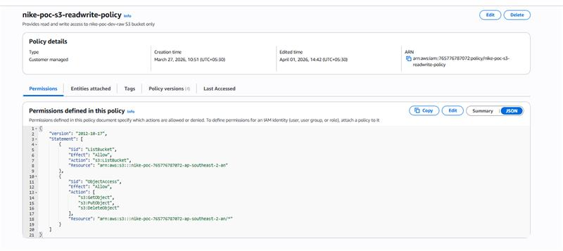

Step-2: Create Role with this id : 765776787072
Role Name: nike-poc-snowflake-role

SS:
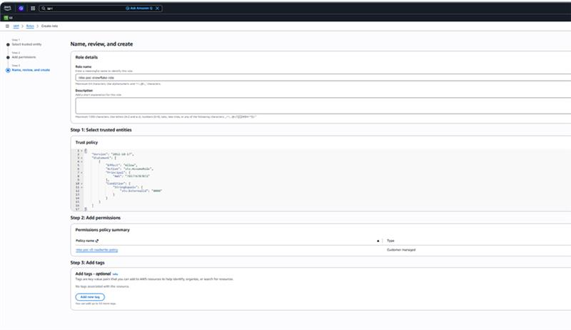

Step-3: run below command on snowflake

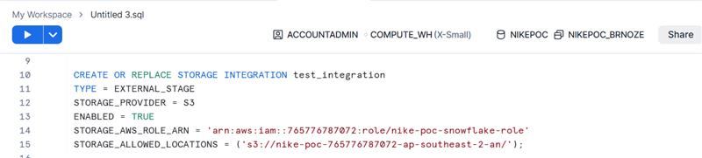

created successfully we have run below command

Step-4:
DESC STORAGE INTEGRATION test_integration;

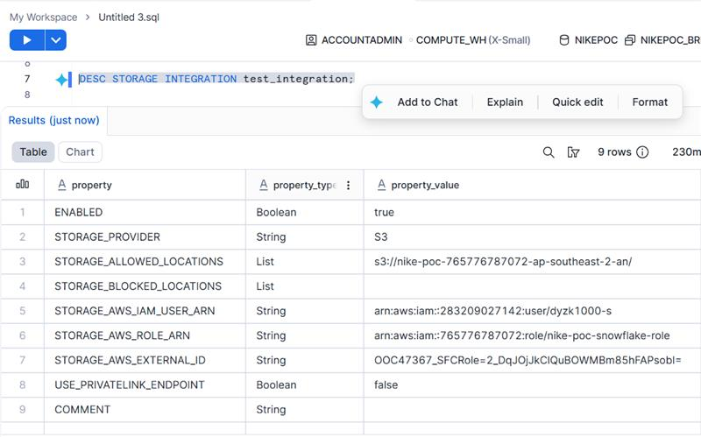

we get these two values after running that command check above SS
Run the DESCRIBE INTEGRATION command in Snowflake and record the values for STORAGE_AWS_IAM_USER_ARN and STORAGE_AWS_EXTERNAL_ID

Step-5: update that two values on role trust relationship

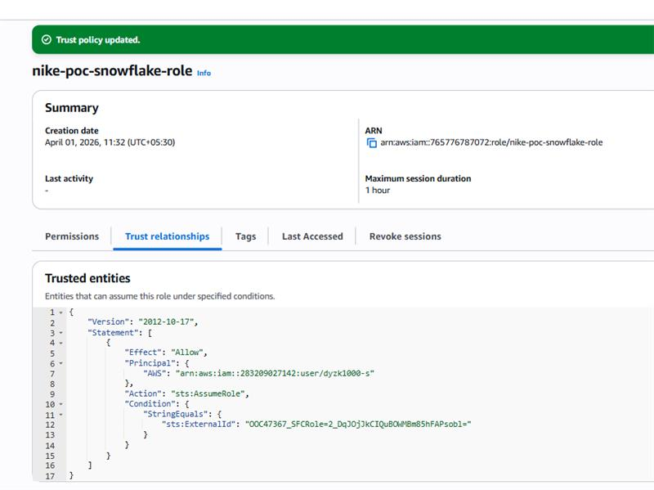

Step-6: run below command on snowflake

CREATE OR REPLACE STAGE test_stage
STORAGE_INTEGRATION = test_integration
URL = 's3://nike-poc-765776787072-ap-southeast-2-an/';

created successfully

step-7: after run below command for verification
LIST @test_stage;

still, we are facing below issue after did all above steps
Error assuming AWS_ROLE: User: arn:aws:iam::283209027142:user/dyzk1000-s is not authorized to perform: sts:AssumeRole on resource: arn:aws:iam::765776787072:role/nike-poc-snowflake-role

SS:
